Book A Ride

# New Ideas:

1. Plan Ride
2. Giving User a Chance to Select Cab
   1. System Provided **(or)**
   2. Manual Selection from the List of Cabs available

**1. Plan Ride:**

By Integrating Services which provide Booking Tickets, we can give User a chance to Plan his rid accordingly.

**Current Scenario:**

**EX_1**: Book Movie ticket, wait for Movie Time and Book a Cab before the Play. If No Cabs available Movie will be missed, this is a Loss.

**EX_2:** Book Flight. If No Cabs available on the day of Journey ,Flight will be missed, this is a Loss.

Like this many scenarios we can observe in our Day to Day Life.

**Solution**:

**Book (Flight/Movie/Restaurant.,,) and Schedule a Cab to that Place From Specified Location with Scheduled Time. “/{id}/plan” is the Api provided in Current Project**

We need to make sure to provide a Cab that day.

Many Other scenarios are explained in **“CareemCaseStudy.pptx”**

**2. Giving User a Chance to Select Cab**

In **Current Scenario,** We are just giving Minimum time of Arrival at the location of user, when he gives his ride details and Select **RIDE NOW** or **RIDE LATER** we Give him a CAB and ETA. In this approach, If User doesn’t reach in time to the given Location; it will lead to CAB Waiting and User need to pay more, which user may feel inconvenience some times.

To solve this, we can add a new Feature in which we give one More option,

1. View and Select
2. Select System Provided(Regular)

**1. View and Select**

In this approach, we list all cab’s with estimated Time, distance route to the location with cab Images. Now, user can select according to his requirements.

**APiS to view: “/view”, same api can be used by Rider to see cab’s available ,**

And Ride requests that are available , To Captain

When User selects a Cab, we just pick the cab and send Request to Captain, if he accepts the request send Captain details to the User. No need of one more Calculation.

**API: /{id}/request/cab/{cabID}**

**Note: we should give a Grace time for this option, if user selects a cab more than the grace period we need to consider that time as waiting and charge according to the waiting charges.**

# Design and Services Provided in Project:

I designed two core Services, one which handles CRUD operations and the Other Ride Operations.

Crud operations are straight forward which deals with creation of users and Riders. Users are divided into three categories.

RIDER

OWNER

Cab Owner

CAPTAIN

USER

Main Implementation and services are provided in Base Classes and Respective Behavior and validations should be provided in Child classes. We should through “**UnsupportedOperationException**” if any service is not implemented by that class.

**UML of CRUD Services**:

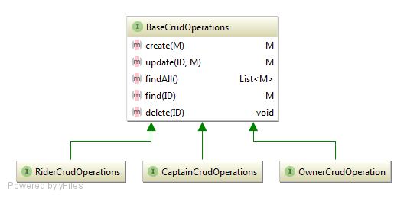

**UML of Ride Services:**

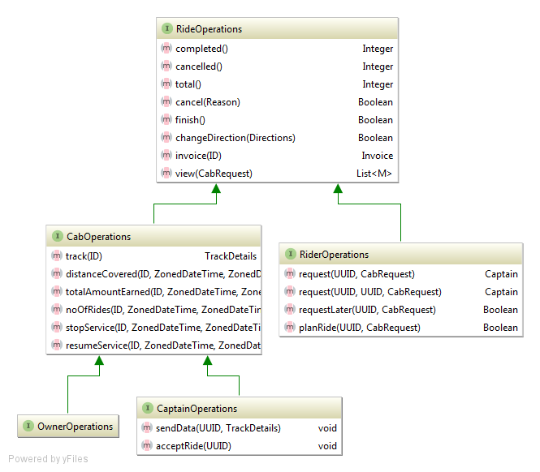

**User UML:**

